FAST PARAMETER ESTIMATION

USING GREEN’S FUNCTIONS

K. Y. Michael Wong
Hong Kong University of
Science and Technology

&

Fuli Li

Xian Jiaotong University

1. Introduction

- In many classification and regression tasks, the choice of hyperparameters is an important factor in determining their performances.

- Most methods are inspired by cross-validation or its variant, leave-one-out validation. They are often tedious.
- We propose a new approach to hyperparameter estimation in large networks, where mean-field theories work.

- Fast: no cross-validations, no matrix inversions, no iterative optimizations.

- The proposed technique is based on the cavity method.

2. Notations

- A network with N >>1 adjustable para-meters w_{j}, j = 1, …, N, or the vector $w$.

- A training set of p examples with inputs $ξ^{μ}$ and outputs y^{μ}, μ = 1, …, p.
- An energy function E of the form

$$E=\sum_{μ}{ε\left(\left\{x_{a}^{μ}\right\},y^{μ}\right)}+R(w)\text{.} \underset{\text{ error function regularization term}}{\begin{aligned} ↑ ↑\end{aligned}}$$

where the activation $x_{a}^{μ}≡w_{a}⋅ξ^{μ}$, and a labels the hidden nodes.

- Learning by gradient descent dynamics:

$$\frac{{\text{dw}}_{j}(t)}{\text{dt}}=−\frac{1}{N}\frac{∂E}{∂w_{j}}\text{.}$$

3. Green’s Functions

- The Green’s function G_{aj,bk}(t,s) is the response of the weight w_{aj} at time t, due to a unit stimulus added at time s to the gradient term with respect to weight w_{bk}, in the limit of a vanishing magnitude of the stimulus.

time
w
stimulation time s
G(t,s)

- Linear response relation: For a small stimulus δh_{aj}(t),

$${δw}_{\text{aj}}=\sum_{b,k}{\int{\text{ds} G_{\text{aj},\text{bk}}(t,s){δh}_{\text{bk}}(s)}}\text{.}$$

- Let $w_{\text{aj}}^{}(t)$ be the network in which example μ is omitted from the training set.

- Treating example μ as a stimulus, we can find the relation between the activation $x_{a}^{μ}≡w_{a}(t)⋅ξ^{μ}$ and the cavity activation $h_{a}^{μ}≡w_{a}^{}(t)⋅ξ^{μ}$.
- At the steady state, linear response relation:

$$h_{a}^{μ}=x_{a}^{μ}+\sum_{b}{γ_{\text{ab}}\frac{∂ε\left(\left\{x_{c}^{μ}\right\},y^{μ}\right)}{∂x_{b}^{μ}}},$$

where γ_{ab} is called the susceptibility.

- Analogy: curve fitting with elastic string:

Predicted value of a data point
= Fitted value of the data point
  - susceptibility
× force of the point on the string

x
y

4. Generalization Error

- Generalization error = error function averaged over the example distribution.

- Leave-one-out generalization error in terms of the cavity activations:

$${\hat{ε}}_{g}=\frac{1}{p}\sum_{μ}{ε\left(\left\{h_{c}^{μ}\right\},y^{μ}\right)}\text{.}$$
- How to Measure the Green’s Functions?

  - Parallel learning in several networks:
  - Reference network: original process
  - Other networks: an added constant stimulus for the weights feeding hidden unit a: δh_{bj}(t) = ηδ_{ab}.
  - At the steady state, the difference with the reference network yields η times the average susceptibility.

6. Results

For comparison:

- Linear Unlearning Leave-One-Out (LULOO) Validation – extending Hansen’s work, need matrix inversion

- Cross validation
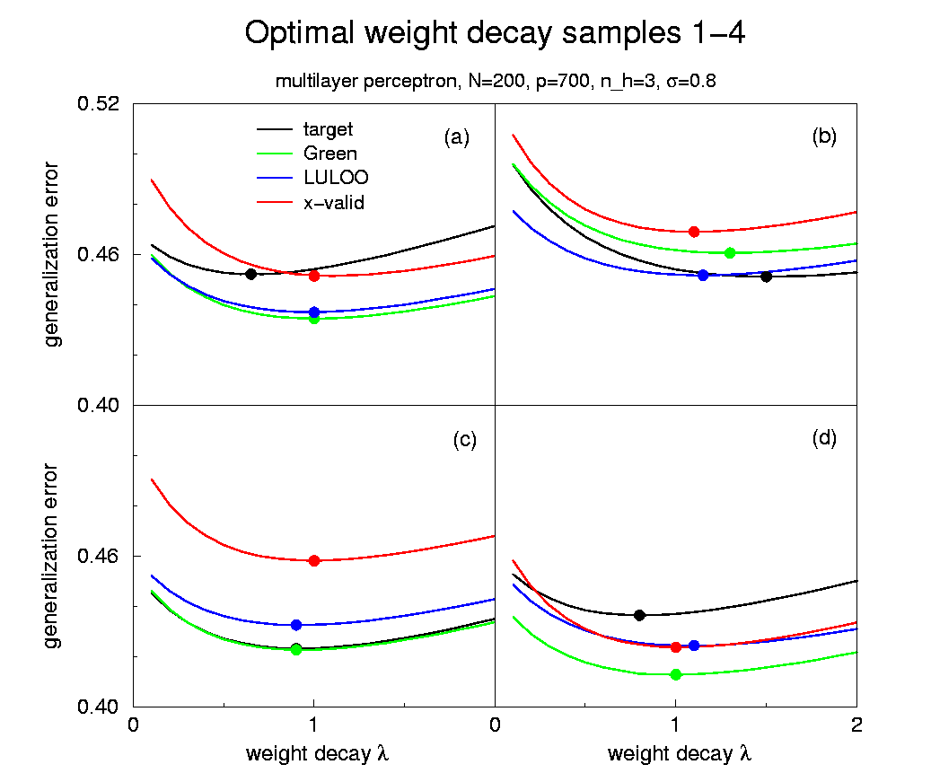
- Green’s functions yield estimates of the optimal weight decay with comparable precision as the other methods.

- Standard deviations in 10 samples:
Green’s | 7fold x-valid | LULOO
0.30 | 0.25 | 0.24

- Standard deviations in 80 samples of single-layer perceptrons:
Green’s | 10fold x-valid | LULOO
1.21 | 1.46 | 1.62

- CPU time for golden search in single-layer perceptrons:
Teacher | Green’s | 10fold x-v | LULOO
1.0 | 1.6 | 3.0 | 4.6

7. Overtraining

- Overtraining: During learning, the generalization error may decrease in the early stage, reaches a minimum and then increases towards the steady state.

- How to determine the early stopping point where the generalization error is minimum (without cross-validation)?
8. Example: Linear Regression

  - Parallel learning in 2 networks:
  - Network 1: original process
  - Network 2: an added initial stimulus δh_{j}(t) = ηδ(t).

  - At time t, the difference between the networks yields η times the average G(t,0).
- Time-translation invariance in linear regression: G(t, s) = G(t – s, 0).

- We can then find the cavity activations and the estimated generalization error at time t, locating the early stopping point.

- Ratio of CPU time:
Green’s | 5-fold x-valid
1 | 1.4
- Good performance:
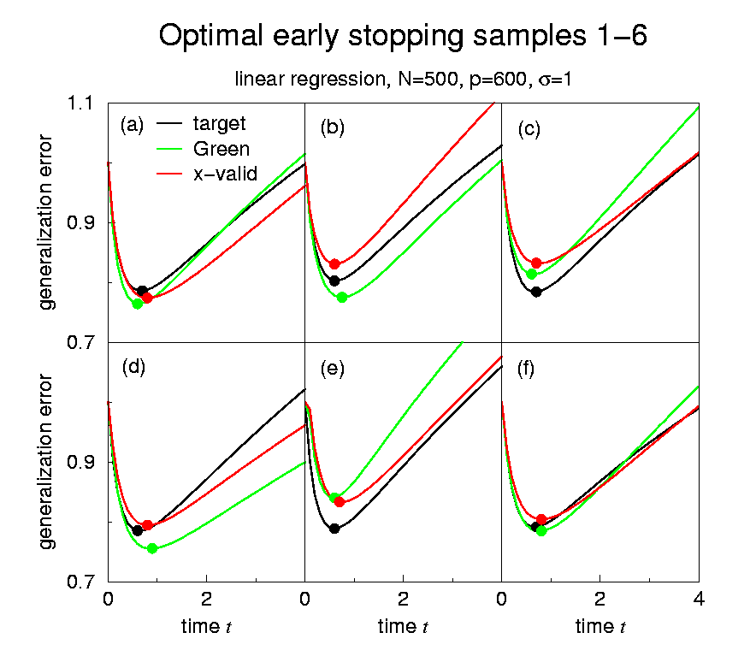
9. Conclusion

  - We have proposed a method for fast estimation of hyperparameters in large networks, based on the linear response relation in the cavity method, and an empirical measurement of Green’s functions.
  - No cross-validations, matrix inversions and iterative optimizations.
  - Further development:
  - Gradients of generalization error: very efficient for multiple hyperparameters
  - Approximations for cases with no time-translational invariance
  - The case of correlated inputs and real data
  - Support vector machines

